**S.V.G.M. GOVERNMENT DEGREE COLLEGE**

**KALYANDURG**

 **NAAC with ‘B’ Grade**





**Coaching for**

**Competitive Exams**

**&**

**P.G Entrance**

**2018-2019**

**Circular**

Date: 01-02-2019

To: All Students

Subject: Free Competitive Examinations Training Program

With the kind permission of Dr. D. Jayarama Reddy, Principal of SVGM Govt. Degree College, Kalyandurg, we are pleased to announce that Sri T. Venkata Ramana, Lecturer in Commerce, will be conducting a Free Competitive Examinations Training Program.

Program Details:

Duration: 30 days

Commencement Date: 04 February 2019

Training Includes:

PG M.Com and other Competitive exams related with Accountancy Subject Example Junior Accounts Officer.

Entrance Preparation (30 days): Comprehensive coaching covering essential topics such as Financial Accounting, Business Organization & Management, Cost & Management, Business Economics and Income Tax.

For: PG M.Com Entrance Preparation (30 days)

Registration:

Interested students are requested to register for the Free Competitive Examinations Training Program at the Commerce Department.

Sd/-

T. Venkata Ramana,

Lecturer in Commerce

SVGM Govt. Degree College, Kalyandurg

**Summary Report:**

**Free Competitive Examinations Training Program**

With the gracious permission of Dr. D. Jayarama Reddy, Principal of SVGM Govt. Degree College, Kalyandurg, Sri T. Venkata Ramana, Lecturer in Commerce spearheaded a commendable initiative to provide free Competitive Examinations training to students. The program commenced on 4th February 2019 and spanned a duration of 30 days.

**Overview:**

The Free Competitive Examinations Training Program catered to the diverse needs of students preparing for a multitude of competitive exams, including PG M.Com Entrance and Other Competitive Exams related with Accounting. Under the expert guidance of Sri T. Venkata Ramana, U. Eswar Reddy and B.K.Ganesh Rao participants received comprehensive coaching and support to enhance their preparation.

**Training Highlights:**

**PG Computer Science Entrance Preparation (30 days):** The program offered rigorous coaching covering essential subjects such as Financial Accounting, Business Organization & Management, Cost & Management, Business Economics, Income Tax and fundamentals of Computers.

**Mock Exam:**

As a pivotal component of the training program, a mock exam was conducted on 14th March 2019, replicating the format and conditions of PG M. Com Entrance exams. This mock exam provided participants with an invaluable opportunity to assess their preparedness and refine their strategies for the actual examinations.

**Conclusion:**

The Free Competitive Examinations Training Program, conducted under the leadership of Sri T. Venkata Ramana, has made a significant impact on the preparation and confidence levels of students aspiring to Commerce Subjects in competitive exams. Through dedicated coaching, expert guidance, and rigorous mock tests, participants have been empowered to pursue their academic and career aspirations with confidence.

Sincerely,

T. Venkata Ramana,

Lecturer in Commerce,

SVGM Govt. Degree College, Kalyandurg.

**2019-20**

**Model PG Entrance Exam**

**Department of Commerce,**

**SVGM Govt. Degree College, Kalyandurg**

**Multiple Choice Questions Answer all the Questions 25 x 1 = 25**

**Section – A: Financial Accounting**

**1.** A company receives a cash payment from a customer for services to be provided in the future. How should this transaction be recorded?

a. Debit Cash, Credit Unearned Revenue b. Debit Cash, Credit Service Revenue

c. Debit Accounts Receivable, Credit Service Revenue

d. Debit Unearned Revenue, Credit Cash

**2.** Which of the following is not a current asset?

a. Cash b. Accounts Receivable c. Inventory d. Equipment

**3.** What is the purpose of the adjusting entry for accrued expenses?

a. To recognize revenue that has been earned but not received

b. To record expenses that have been incurred but not yet paid

c. To adjust the book value of an asset

d. To account for the depreciation of equipment

**4.** What is the formula for calculating the current ratio?

a. Current Ratio = Current Assets / Current Liabilities

b. Current Ratio = Total Assets / Total Liabilities

c. Current Ratio = Net Income / Total Assets

d. Current Ratio = Equity / Total Assets

**5.** How does the straight-line method of depreciation calculate annual depreciation expense?

a. (Cost - Salvage Value) / Useful Life b. Cost / Useful Life

c. (Cost - Residual Value) / Useful Life d. (Cost + Salvage Value) / Useful Life

**Section – B: Business organization & Management**

**6.** What is the purpose of a SWOT analysis in strategic management?

a. To identify internal strengths and weaknesses

b. To assess the external opportunities and threats

c. To develop marketing strategies d. All of the above

**7.** Which of the following is a function of human resource management?

a. Financial planning b. Employee training and development

c. Marketing strategy d. Product design

**8.** What is the purpose of job enrichment in human resource management?

a. To increase the number of employees in the organization

b. To enhance employee job satisfaction and motivation

c. To reduce employee turnover d. To streamline the organizational structure

**9.** In the context of change management, what is the "unfreezing" stage?

a. Preparing employees for change b. Implementing the change

c. Ensuring the change becomes part of the organizational culture

d. Creating a sense of urgency for change

**10.** Which of the following is a component of the communication process in management?

a. Feedback b. Planning c. Controlling d. Organizing

**Section – C: Income Tax**

**11.** What is the purpose of the Alternative Minimum Tax (AMT) credit?

a. To reduce the tax liability for high-income individuals

b. To offset the cost of education c. To encourage charitable giving

d. To provide a credit for taxpayers subject to the AMT

**12.** What is the purpose of Form 4684?

a. To report mortgage interest paid

b. To report tuition payments made to eligible educational institutions

c. To report income from self-employment

d. To report casualty and theft losses for tax purposes

**13.** Which of the following is a tax-deductible expense for small businesses?

a. Personal travel expenses b. Employee salaries

c. Entertainment expenses for personal use d. Personal clothing expenses

**14.** What is the purpose of the Lifetime Learning Credit?

a. To provide a credit for child care expenses b. To offset the cost of education

c. To reduce the tax liability for taxpayers with qualifying children

d. To encourage family planning

**15.** How is income from dividends taxed in the United States?

a. Taxed at a lower capital gains rate

b. Taxed at the individual's ordinary income tax rate

c. Not subject to taxation d. Taxed at a flat rate of 15%

**Section – D: Fundamentals of Computers**

**16.** Which of the following is a non-volatile memory type?

a. RAM b. ROM c. Cache Memory d. Flash Memory

**17.** What does SQL stand for?

a. Structured Question Language b. System Query Language

c. Sequential Query Language d. Structured Query Language

**18.** What is the purpose of the Ctrl + Z keyboard shortcut in most applications?

a. Copy b. Undo c. Paste d. Cut

**19.** Which programming language is often used for developing mobile applications?

a. C# b. Swift c. Ruby d. PHP

**20.** What is the function of a GPU (Graphics Processing Unit)?

a. Execute software programs b. Perform arithmetic and logical operations

c. Control input devices d. Handle graphics rendering and processing

**Section – E: Cost & Management Accounting**

**21.** Which method allocates indirect costs based on the actual usage of resources?

a. Activity-Based Costing (ABC) b. Traditional costing

c. Direct costing d. Variable costing

**22.** What is the purpose of a cost allocation base in cost accounting?

a. To calculate fixed costs b. To allocate indirect costs to cost objects

c. To determine variable costs d. To calculate contribution margin

**23.** Which costing method is most suitable for decision-making and short-term planning?

a. Absorption costing b. Variable costing c. Job costing d. Process costing

**24.** What is the purpose of a cost variance analysis?

a. To identify areas of cost overruns b. To calculate total costs

c. To determine selling prices d. To allocate fixed costs

**25.** Which of the following is considered a period cost?

a. Direct materials b. Direct labor

c. Manufacturing overhead d. Selling and administrative expenses

**Photo Evidences**:

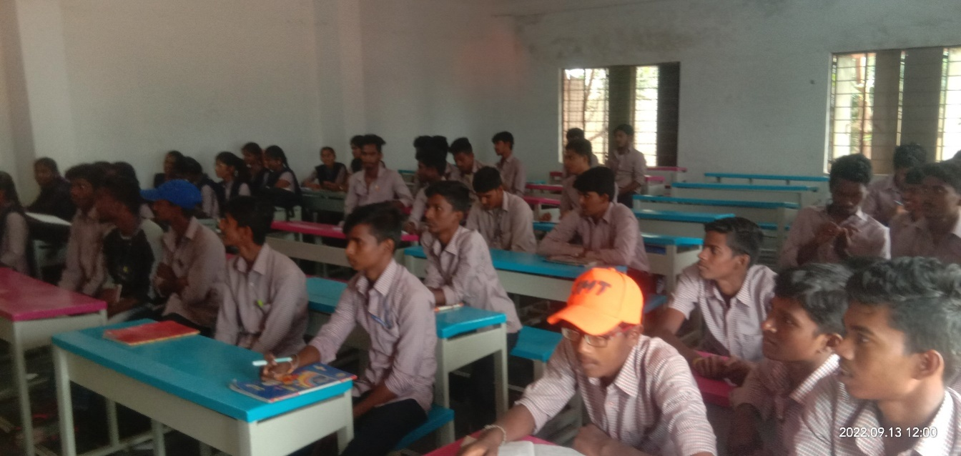

Photos for Evidence

